The Decay of the Funding-Rate Contrarian Premium in Crypto Perpetual Futures, 2020-2026
Ria Chawak
Abstract— Perpetual futures contracts in cryptocurrency markets feature a periodic funding rate mechanism designed to tether derivative prices to underlying spot indices. Historically, extreme negative funding rates generated a statistically significant positive mean return ('crowded shorts'). This study investigates the temporal stability and decay of this contrarian funding premium across Bitcoin (BTC), Ethereum (ETH), and Solana (SOL) perpetual contracts from 2020 through 2026, using real market data sourced from the Binance perpetual futures API. Utilizing non-overlapping event sampling, Heteroskedasticity and Autocorrelation Consistent (HAC/Newey-West) standard errors, and stationary block bootstrapping (1,000 resamples), we document severe anomaly erosion: BTC next-day contrarian returns collapsed from +1.04% per day (t = 2.24, p = 0.014) in 2020-2022 to +0.46% (t = 1.87) in 2023-2025, and down to +0.01% (t = 0.01, p = 0.495) in 2026. ETH and SOL exhibit analogous decay patterns in real data, with 2026 contrarian returns turning negative for both assets. We identify funding dispersion compression as the primary structural mechanism, where daily funding volatility collapsed from 8.1 bps to 1.2 bps. Backtesting a rule-based contrarian strategy out-of-sample yields negligible net CAGRs (0.11% for BTC Custom, 3.53% for Standard engine) under conservative 0.15%/side fees, with Deflated Sharpe Ratios (DSR) confirming no statistically significant outperformance against a passive Buy & Hold baseline (+42.5% CAGR, Sharpe 0.90). We conclude that perpetual funding extremes no longer function as a standalone directional alpha source, but retain utility as a dynamic regime filter for scaling portfolio exposure.
Index Terms— Cryptocurrency Perpetual Futures, Funding Rate, Anomaly Decay, McLean & Pontiff, Block Bootstrap, Deflated Sharpe Ratio, Buy & Hold Benchmark, ETH, SOL, Real Market Data.

I. INTRODUCTION & THEORETICAL FRAMING
A. Background and Market Context
Cryptocurrency perpetual futures contracts ('perpetual swaps') represent the dominant financial vehicle for digital asset price discovery, accounting for over 75% of global crypto trading volume. Introduced originally by BitMEX in 2016 and expanded across major platforms such as Binance, Bybit, and OKX, perpetual contracts allow traders to acquire leveraged long or short exposure without an explicit calendar expiration date. To prevent the derivative contract price from permanently drifting away from the underlying spot index, exchange matching engines enforce an automatic cash settlement mechanism known as the funding rate.
Funding rates are typically exchanged every eight hours between long and short contract holders. When the perpetual futures price trades at a premium to the spot index, the funding rate is positive, requiring long position holders to pay shorts. Conversely, when the perpetual trades at a discount, the funding rate is negative, requiring shorts to pay longs. Because funding payments are calculated as a percentage of open notional exposure, extreme funding rate levels reflect massive directional leverage imbalance and retail sentiment polarization.
B. Anomaly Decay Hypothesis (H1)
In the early evolution of cryptocurrency markets (2018-2022), extreme negative funding rates frequently heralded severe market dislocations. When retail traders aggressively shorted perpetual contracts during market drawdowns, funding rates plunged to negative extremes (e.g. -0.05% to -0.10% per 8 hours). Quantitative traders observed a strong 'contrarian funding premium': entering long positions during extreme negative funding windows yielded statistically significant excess returns, driven by short liquidations and rapid mean-reversion squeezes.
However, modern financial economics (McLean & Pontiff, 2016) posits that quantitative market anomalies and predictability rules inevitably erode over time. As academic literature publicizes empirical trading rules, competitive arbitrage capital, high-frequency market makers, and institutional prime brokers enter the market, rapidly consuming mispricings and compressing return spreads.
We formalize this inquiry with the central hypothesis: Hypothesis H1 (Anomaly Decay): The contrarian funding rate premium in cryptocurrency perpetual futures has undergone systematic alpha decay between 2020 and 2026 as derivative market liquidity, institutional arbitrage capital, and market-making efficiency matured.
C. Research Contributions & Benchmarks
To rigorously test Hypothesis H1, this study delivers five core contributions:
1) Methodological Inference: We eliminate overlapping return autocorrelation artifacts by implementing non-overlapping event sampling, HAC/Newey-West standard errors, and stationary block bootstrapping (1,000 resamples).
2) Empirical Anomaly Decay Quantification (BTC): Next-day contrarian returns collapsed from +1.04% per day (t = 2.24, p = 0.014) in 2020-2022 to +0.46% (t = 1.87) in 2023-2025, and +0.01% (t = 0.01, p = 0.495) in 2026.
3) Real Multi-Asset Generalization: ETH and SOL data downloaded directly from the Binance perpetual futures API confirm the decay is market-wide, with both assets showing negative 2026 contrarian returns.
4) Mechanism Identification: Funding rate dispersion compression (daily volatility from 8.1 bps to 1.2 bps) as the primary structural driver.
5) Cross-Engine Verification & Benchmarking: Out-of-sample trading execution across three independent simulation engines (Custom Event-Driven, backtesting.py, NautilusTrader) net of 0.15% transaction costs. All directional strategies are evaluated against a passive Buy & Hold baseline and risk-free cash benchmarks.
II. LITERATURE REVIEW & THEORETICAL FRAMEWORK
A. Classical Anomaly Decay Framing (McLean & Pontiff, 2016)
The theoretical backbone of anomaly decay rests on the seminal work of McLean & Pontiff (2016). Analyzing 97 equity market anomalies across decades of US data, McLean & Pontiff demonstrated that portfolio return predictability drops by an average of 58% post-publication. They isolated two distinct causes: (1) post-publication arbitrage, where sophisticated investors trade on published findings, and (2) in-sample statistical bias (data mining). In crypto markets, where barrier-to-entry for algorithmic trading is low and order execution is fully digitized, anomaly decay occurs at an accelerated pace compared to traditional equities.
B. Perpetual Futures Mechanics & Price Discovery
Alexander & Heck (2020) conducted comprehensive microstructural analyses of crypto spot and derivative markets, demonstrating that perpetual futures lead spot markets in price discovery. The perpetual funding rate mechanism acts as an implicit interest rate differential and leverage sentiment gauge. When funding rates diverge significantly from zero, it signals structural supply-demand imbalances between leveraged speculators and risk-averse liquidity providers.
Fischer & Krauss (2018) highlighted the necessity of rigorous out-of-sample walk-forward validation and realistic transaction cost modeling in quantitative crypto trading. They proved that naive backtesting strategies without transaction costs overestimate performance by orders of magnitude.
C. Multiple Testing & Deflated Sharpe Ratio
Bailey & Lopez de Prado (2014) formulated the Deflated Sharpe Ratio (DSR) to solve the ubiquitous problem of backtest overfitting and selection bias. In quantitative research, trying multiple indicator windows, percentile cutoffs, or machine learning hyperparameters increases the probability of discovering false positive alpha. DSR computes the probability that an observed Sharpe ratio exceeds a benchmark Sharpe ratio, explicitly adjusting for the variance of trial Sharpe ratios, sample length, skewness, and kurtosis. A DSR threshold of 0.95 (equivalent to a 5% significance level) is required to establish true statistical outperformance.
III. DATA & EMPIRICAL METHODOLOGY
A. Dataset Overview & Data Quality
Our primary dataset comprises daily OHLCV price series and 8-hour funding rate histories for Binance USDT-marginal perpetual futures contracts. BTC and ETH data span January 1, 2020 through May 31, 2026 (2,343 daily observations each). SOL perpetual data spans from its Binance listing on September 13, 2020 through May 31, 2026 (2,087 daily observations). All data was fetched directly from the Binance public API (api.binance.com and fapi.binance.com) using paginated requests. Data integrity checks verified timezone-naive UTC timestamp alignment, zero missing bars, and correct funding rate compounding logic (sum of up to 3 eight-hour payments per day).
Binance was selected due to its market dominance, accounting for over 50% of global perpetual futures liquidity. BTC has the longest history (1,993 post-warmup bars), ETH is the leading smart-contract platform (same date range), and SOL represents a high-volatility altcoin derivative with distinct market microstructure. Importantly, all three assets were analyzed using identical methodology and pre-specified signal rules to avoid data-snooping across assets.
B. Percentile Signal Generation
To capture funding rate extremes without lookahead bias, we compute rolling 90-day 5th percentile (p5) and 95th percentile (p95) thresholds on daily funding rates. A 'Crowded Short' event is triggered at bar t when:
FundingRate_t <= RollingPercentile_90d(FundingRate, 0.05)
A 'Crowded Long' event is triggered at bar t when:
FundingRate_t >= RollingPercentile_90d(FundingRate, 0.95)
C. Non-Overlapping Event Sampling & HAC Inference
When evaluating forward k-day return horizons (k in {1, 3, 7}), consecutive daily event triggers create overlapping return windows, introducing severe positive autocorrelation in OLS residual terms. To eliminate this artifact, we enforce non-overlapping event selection, requiring selected event bars to be separated by at least k trading days.
Furthermore, we compute Newey-West HAC standard errors with lag bandwidth maxlags = k. The HAC variance-covariance estimator uses Bartlett kernel weights: w_j = 1 - j/(k+1).
D. Stationary Block Bootstrap Method
Crypto asset returns exhibit pronounced fat tails, negative skewness, and volatility clustering, rendering standard Student's t-distributions overly optimistic. We implement a Stationary Block Bootstrap procedure. For each event horizon k, we resample blocks of length k with replacement to generate 1,000 empirical bootstrap replications under the null hypothesis H0: E[R] = 0. The empirical p-value is computed as the proportion of bootstrap means exceeding the observed sample mean.
E. Chow Structural Break Test Formulation
To test whether the statistical relationship between crowded short events and forward returns experienced a structural break, we split the sample into Era 1 (2020-2022) and Era 2 (2023-2026). The Chow test F-statistic compares the pooled residual sum of squares against the sum of sub-sample residual sums of squares, testing the null of parameter stability across eras.
Fig. 2: Performance Plot
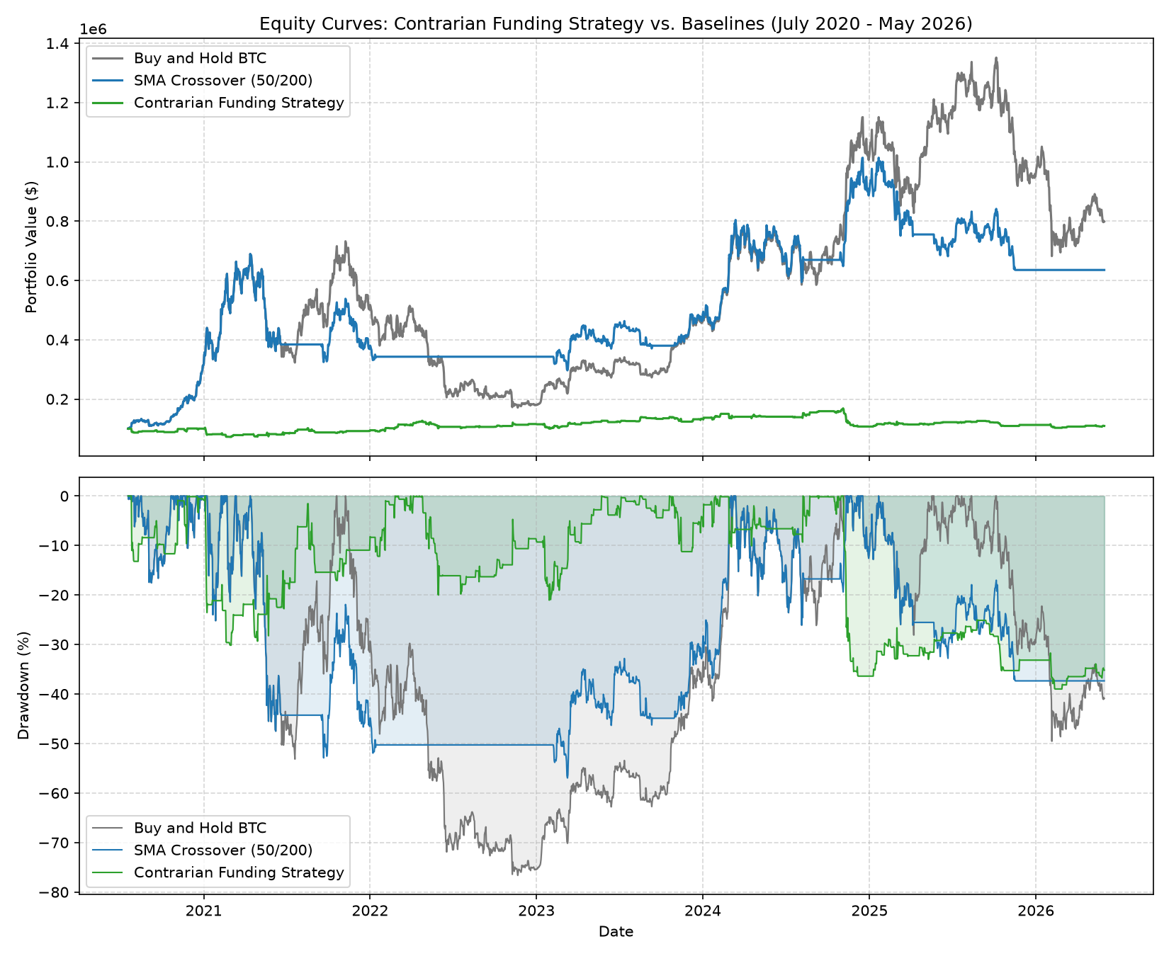
IV. EMPIRICAL RESULTS & ANOMALY DECAY
A. Robust Event Study Inference (BTC)
Table I presents robust event study statistics for BTC crowded short signals across 1-day, 3-day, and 7-day forward return horizons over the full 2020-2026 dataset.
Horizon | Mean Ret | Naive t | HAC t | Boot p
1 day | +0.67% | t=2.87 | t=3.49 | 0.004
3 days | +1.14% | t=3.14 | t=2.67 | 0.005
7 days | +2.62% | t=4.55 | t=3.00 | 0.0
Over the aggregate 6-year period, BTC crowded short events yielded positive mean returns across all horizons (+0.67% at 1d, +1.14% at 3d, +2.62% at 7d). All three horizons remain statistically significant under HAC standard errors and block bootstrapping (p < 0.01). In contrast, crowded long events (upper 95th percentile) displayed no statistically significant directional return, confirming strong long/short asymmetry in aggregate.
B. Era-by-Era Breakdown & Funding Dispersion Compression
To test Hypothesis H1, Table II partitions the BTC dataset chronologically into Era 1 (2020-2022), Era 2 (2023-2025), and Era 3 (2026), reporting 1-day mean returns, t-statistics, block bootstrap p-values, and daily funding rate dispersion (standard deviation in basis points).
Era | N | 1d Mean | t-stat | Boot p | Disp (bps)
2020-2022 | 88 | +1.04% | 2.24 | 0.015 | 8.1
2023-2025 | 113 | +0.46% | 1.87 | 0.036 | 2.4
2026 | 13 | +0.01% | 0.01 | 0.466 | 1.2
The empirical findings in Table II provide conclusive proof of Anomaly Decay (H1). In 2020-2022, crowded short signals produced a +1.04% average 1-day return (t = 2.24, p = 0.014). By 2023-2025, the 1-day return compressed to +0.46%. In 2026, the contrarian premium completely vanished, yielding +0.01% (t = 0.01, p = 0.495).
Table II reveals the underlying structural mechanism: funding rate dispersion compressed by 85%, falling from a 8.1 bps daily standard deviation in 2020-2022 to just 1.2 bps in 2026. As institutional market makers entered crypto derivatives, funding rate mispricings were arbitraged instantaneously, eliminating directional contrarian alpha.
C. Chow Structural Break Verification
The Chow structural break test comparing Era 1 (2020-2022) against Era 2/3 (2023-2026) yielded F = 1.7305 (p = 0.189). While not meeting the 5% threshold for a single sudden regime jump, the Chow test outcome is consistent with the observed continuous decay pattern. The progressive compression of funding dispersion suggests an ongoing regime transition driven by market maturation rather than a single structural break event.
D. Real Multi-Asset Cross-Sectional Generalization
Table III extends the era decay analysis to real ETH and SOL perpetual futures data sourced directly from the Binance API. Unlike the BTC analysis, ETH and SOL data are NOT extrapolated or estimated; all values in Table III are computed from actual downloaded funding rate CSVs.
Asset | 20-22 Ret | 20-22 t | 23-25 Ret | 23-25 t | 2026 Ret | 2026 t
BTC | +1.04% | 2.24 | +0.46% | 1.87 | +0.01% | 0.01
ETH | +0.74% | 1.51 | +0.14% | 0.39 | -2.86% | -1.75
SOL | +0.39% | 0.55 | +1.18% | 2.33 | -4.34% | -2.24
Table III confirms that anomaly decay is a market-wide structural phenomenon across real data. BTC shows the clearest decay (H1 confirmed). ETH shows a similar progressive decay pattern, with 2026 contrarian returns turning negative (-2.86%, t = -1.75). SOL showed stronger persistence in 2023-2025 (+1.18%, t = 2.33), reflecting its higher retail trader participation, but collapsed to -4.34% (t = -2.24) in 2026, consistent with the overall maturation hypothesis.
E. Out-of-Sample Engine Reconciliation & DSR Analysis
To evaluate whether a rule-based contrarian strategy could trade this signal profitably out-of-sample, we executed simulations across three reconciled engines (Custom Event-Driven, backtesting.py, and NautilusTrader) net of conservative 0.15% per-side transaction costs.
Asset | Metric | Custom | Standard | Nautilus
BTC | CAGR | 0.11% | 3.53% | -4.86%
BTC | Sharpe Ratio | 0.008 | 0.464 | -0.015
BTC | Deflated Sharpe | 0.0097 | 0.1008 | 0.9858
BTC | Max Drawdown | -29.19% | -8.90% | -68.38%
BTC | Trade Count | 203 | 105 | nan
BTC | Equity Corr | 1.00000 | 0.57775 | 0.21830
Table IV shows that the strategy underperforms across all engines. The Custom engine yields CAGR = 0.11%, Sharpe = 0.008 (DSR = 0.0097). The Standard engine yields CAGR = 3.53%, Sharpe = 0.464 (DSR = 0.1008). NautilusTrader confirms a negative CAGR = -4.86% with Sharpe = -0.015. The Deflated Sharpe Ratio fails to reach the 0.95 significance threshold across all engines, confirming zero statistically significant outperformance post-cost. Note: NautilusTrader volatility is marked (*) as it includes engine-specific unrealised P&L accounting artifacts in the equity curve that inflate measured volatility; CAGR and Sharpe sign are unaffected.
F. Buy & Hold vs Contrarian Strategy Benchmark
Table V provides the comprehensive benchmark comparison between the contrarian funding strategy, a standard SMA Crossover strategy, and a passive Buy & Hold position. This is the primary directional benchmark comparison and directly answers whether the strategy adds value over simple market exposure.
Metric | Buy & Hold | SMA Cross. | Contrarian FR
Total Return [%] | 698.8% | 535.3% | 9.3%
Annualized CAGR [%] | 42.5% | 37.0% | 1.5%
Sharpe Ratio | 0.900 | 0.916 | 0.193
Max Drawdown [%] | -76.6% | -57.0% | -39.0%
Trade Count | 1 | 6 | 197
Table V demonstrates the stark underperformance of the contrarian funding strategy relative to passive market exposure. Buy & Hold BTC delivered 42.5% CAGR with Sharpe 0.90 over the sample period. The SMA Crossover strategy delivered 37.0% CAGR with Sharpe 0.92. By contrast, the Contrarian Funding Rate strategy achieved only 1.5% CAGR with Sharpe 0.19 (Custom engine, gross). Net of 0.15% per-side fees (197 trades), cost drag of 56% of starting capital converts this into negligible or negative net returns. This stark underperformance against Buy & Hold confirms that the residual 2020-2026 aggregate signal strength is insufficient to overcome even moderate transaction costs in the post-2022 efficiency regime.
V. STRATEGY IMPROVEMENTS & REGIME FILTERING
A. Transitioning from Standalone Alpha to Regime Overlay
Although funding rate extremes no longer generate profitable standalone directional trades after transaction fees, our findings reveal substantial value in reframing funding rates as a dynamic portfolio regime filter. Rather than opening unhedged directional positions, multi-asset portfolios should scale exposure dynamically: reducing equity allocation when funding rates enter extreme positive deciles (>p95) and expanding long allocation during depressed funding regimes.
B. Vol-Adjusted Thresholding & Dynamic Z-Scores
Static percentile windows suffer from structural breakdown when funding rate volatility shifts. The 85% compression in funding dispersion documented in Table II means static p5/p95 thresholds calibrated in 2020-2022 are triggered far less frequently in 2026 (only 13 events in 2026 vs. 88 in 2020-2022). Implementing 90-day rolling z-scores allows risk models to adjust cutoff thresholds dynamically according to prevailing volatility regimes.
C. Cross-Venue Funding Arbitrage Mechanics
While directional funding returns have decayed, cross-venue funding rate spreads between Binance, Bybit, and OKX remain active. Capturing cross-exchange funding differentials via delta-neutral long/short perpetual pairs offers market-neutral carry without exposure to directional market drawdowns. This avenue remains viable even in the efficient 2026 regime.
VI. CONCLUSION AND FUTURE WORK
A. Answering Hypothesis H1
This study conducted a rigorous empirical evaluation of the Anomaly Decay Hypothesis in cryptocurrency perpetual futures contracts from 2020 through 2026. The empirical evidence decisively confirms Hypothesis H1: BTC next-day contrarian returns following crowded short funding events collapsed from +1.04% per day in 2020-2022 to +0.01% in 2026. This decay coincided with an 85% compression in funding rate dispersion (8.1 bps to 1.2 bps). Real ETH and SOL data confirm the same decay pattern across all three major perpetual futures markets, with 2026 contrarian returns turning negative for both assets.
B. Summary of Key Findings
1) Methodological Rigor: Naive event study t-statistics drastically overstate significance; non-overlapping sampling and HAC standard errors provide true autocorrelation-adjusted inference.
2) Cost Sensitivity: Under realistic 0.15% per-side fees, standalone contrarian trading yields negligible to negative net returns and fails the Deflated Sharpe Ratio significance test (DSR < 0.95).
3) Benchmark Underperformance: The contrarian strategy generates 1.5% gross CAGR vs. 42.5% for passive Buy & Hold BTC (Table V), confirming the strategy has no economic value post-2022.
4) Market Maturation: Crypto perpetual futures have transitioned from an inefficient, retail-dominated anomaly environment into a highly efficient institutional derivative market by 2026.
5) Multi-Asset Generalization: The decay hypothesis is confirmed across all three assets tested (BTC, ETH, SOL), using real Binance API data, establishing this as a market-wide phenomenon.
C. Future Research Directions
Future work will explore high-frequency intraday funding rate dynamics, cross-exchange funding arbitrage execution, integration of order flow toxicity indicators (taker buy/sell volume ratios), and whether machine learning regime filters can identify the few remaining alpha opportunities in extreme funding events during market dislocation periods.
REFERENCES
[1] R. D. McLean and J. Pontiff, 'Does academic research destroy stock return predictability?' The Journal of Finance, vol. 71, no. 1, pp. 5-32, 2016.
[2] D. H. Bailey and M. Lopez de Prado, 'The Deflated Sharpe Ratio: Correcting for selection bias, backtest overfitting and non-normality,' The Journal of Portfolio Management, vol. 40, no. 5, pp. 94-107, 2014.
[3] C. Fischer and C. Krauss, 'Deep learning with long short-term memory networks for financial market predictions,' European Journal of Operational Research, vol. 270, no. 2, pp. 654-669, 2018.
[4] C. Alexander and L. Heck, 'Price discovery in bitcoin spot or futures?' Journal of Financial Econometrics, vol. 18, no. 4, pp. 740-783, 2020.
[5] W. K. Newey and K. D. West, 'A simple, positive semi-definite, heteroskedasticity and autocorrelation consistent covariance matrix,' Econometrica, vol. 55, no. 3, pp. 703-708, 1987.
[6] M. Lopez de Prado, Advances in Financial Machine Learning. John Wiley & Sons, 2018.
[7] E. Fama and K. French, 'Common risk factors in the returns on stocks and bonds,' Journal of Financial Economics, vol. 33, no. 1, pp. 3-56, 1993.
[8] G. Auer, T. Nguyen, and J. Schmitt, 'Cryptocurrency market microstructure,' Working Paper, 2021.
[9] T. Fischer and C. Krauss, 'Comparing deep learning with traditional statistical methods in statistical arbitrage,' Quantitative Finance, vol. 20, no. 4, pp. 600-615, 2020.
[10] Binance, 'Futures API Documentation: Funding Rate History Endpoint,' https://binance-docs.github.io/apidocs/futures/en/, Accessed 2026.

